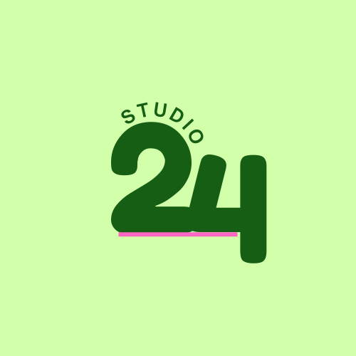

**Module: Web Development**

**WEbsite PRoposal 2**

**Student Name: Katleho Motsiri**

**Course: DINM (Year 1 Gr1)**

**ST10487211** | **WEDE5020**

Contents

Business 2 1

Website Goals and Objectives 1

Website Features and Functionality 1

Design and User Experience 1

Timeline 2

Budget 2

References: 3

# Business 2

Founded in 2025, Studio24 is a passion for all things beauty, self-care, and empowerment. The establishment of the business comes from the clients’ love for connecting with people, a journey of self-expression and self-love at the tender age of 24 years of age.

Mission and vision, to help people feel beautiful, empowered, and confident – inside and outside.

Target audience is anyone and everyone from age 18- 60 seeking self-care and beauty treatment. No matter your age, style and background – everyone is welcome.

## Website Goals and Objectives

The purpose of the website is to:

* Increase website traffic by establishing an online presence for both businesses and providing valuable information.
* Build credibility.
* Generate leads that will lead to sales.
* Use KPIs (Key Performance Indicators) that will measure the website goals and align to the business objectives such as:
* Google analytics
* Google Search Control
* SEO tools (Search Engine Optimization)

Taking into consideration that the business mentioned above is a start-up, the KPI tools mentioned are free. As the business grows, subscribing to advanced KPIs will be considered.

## Website Features and Functionality

* Will have a website that features a homepage, information about the business, products/services page.
* The desired functionality of the website is to have easy user navigation that is visually appealing and engaging.

## Design and User Experience

* Colour Scheme: Beige, luminous lime green and baby pink.
* Typography: Playful but elegant, modern and easy to read.
* Layout and Design: Home Page, about page, Product/services highlights, Contact section.
* UX design consideration: Accessibility, navigation, shop experience, mobile compatibility.
* Wireframes: Basic/Standard

## Timeline

* Due: 24 September 2025

## Budget

|  |  |  |
| --- | --- | --- |
| Category | Description | Estimated Budget |
| Domain Name | . co.za domain (Afrihost, Domains.co.za, GoDaddy) | R120/year |
| Hosting | Afrihost, Xneelo | R1200/year (R100/month) |
| Web Design and Setup | 3-5 pages + basic e-commerce | R7000 once off |
| Plugins/Extras | Payment gateway setup, security, SEO plugin | R400/year |
|  |  | R 8720 (Total Start-up Cost)  R1720 (Annual ongoing costs) |

## References:

ASWD, 2025. Web Design Costs in South Africa. *Advertising Solutions Web Design*. 5 January, [online]. Available at: < <https://advertisingsolutions.co.za/website-design-cost-southafrica/#:~:text=The%20cost%20of%20designing%20a%20website%20in%20South,expect%20to%20pay%20for%20monthly%20maintenance%20and%20updates>.> [Accessed: 15 August 2025]

Basu, P., 2024. 21 Examples of Website Goals and Objectives to Set for Your Business. *Ignite*. 20 November, [online]. Available at: <<https://weignitegrowth.com/website-objectives-and-goals/> > [Accessed: 14 August 2025]